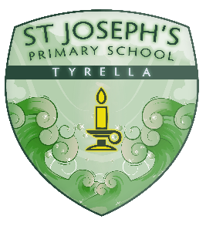
St Joseph’s Primary School
24, Tyrella Road,
Downpatrick
BT30 8DF
Tel: 028 44851600
E Mail : rcolhoun734@c2kni.net
Principal : Mrs S Mc Mullan BEd.Hons. , MEd , PQSH
17/06/20
Dear parents/guardians,
Yesterday, the Minister of Education, Peter Weir, informed principals that he has established an Education Restart Programme to address the phased reopening of schools. The Restart Programme Board will consider the following:
- Physical protection of staff and pupils
- Well-being of staff and pupils
- Vulnerable learners and SEN services
- Standards and learning
- A new normal – new school day arrangements
As we receive guidance and direction from the Department of Education, we will be in a position to finalise our arrangements for a phased reopening. I recognise that parents are anxious for details about how the pupils will return in the new term and that is why we want to ensure that the information we give you is as accurate as possible and in line with DE guidance.
I envisage that this will incorporate a new blended approach to education where our pupils will be educated through a mixture of remote learning at home and face-to-face teaching at school. Therefore, not all pupils will return to school as normal at the beginning of the next academic year and may only attend school on a timetabled basis.
When we receive the guidance from the Minister we will see how we can make it work best in our school context and also adhering to Public Health Agency guidance as well as the Northern Ireland Executive's "Coronoavirus Executive Approach to Decision-Making" paper. A key point to remember is that with a fluid situation, the playing field may look different again in ten weeks’ time.
We have been told that the guidance can and will be reviewed throughout the course of the summer weeks. We will try to work out our plan for a safe return for all after the summer. School is going to be quite different in the new term and every decision that we make has implications for so much of our existing practice. Our priority throughout will be to get children back into school for as long as we can each week, whilst ensuring that we are implementing all PHA and DE guidelines. I will be informing you next week of our plans after careful consideration of the guidance issued. Thank you once again for your continued support.
Yours sincerely,
Mrs Mc Mullan ( Principal )

